How to running backend code on your computer:
- Create database
- download PostgreSQL:
website: https://www.postgresql.org/download/windows/ click “Download the installer”
• Check pgAdmin to manage the database.
• Set the PostgreSQL account password ( Remember the password for the postgres user).
• The default port number is 5432 (do not change it).
Verify that PostgreSQL is installed successfully Run the command in the terminal: psql --version
- Create a database
Open pgAdmin (the database management tool included with PostgreSQL installation).
Log in using the postgres account and password.
Right-click "Servers → PostgreSQL" on the left and select "Create → Database...".
Enter the database name (such as mydatabase) and click "Save".
Or use the computer terminal to enter psql -U postgres -d mydatabase, enter the account and password, and enter the database interactive mode: Enter the command: CREATE DATABASE mydatabase

- Setting up the project
Create a folder locally and make sure the project structure is as shown:
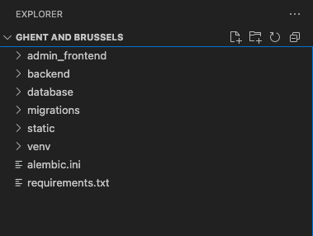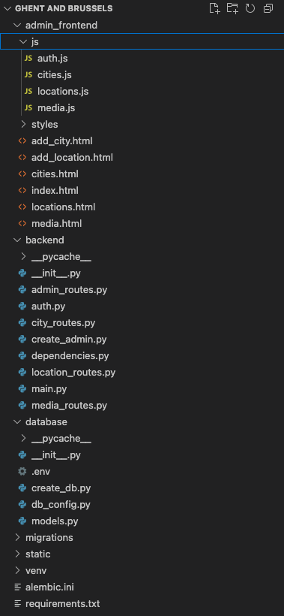You can ignore the “migrations”, “static” and “venv” files for now. Their functions will be explained later.
- Building a virtual environment
Open the VS code terminal, enter the project root directory, and enter the command python -m venv venv or python3 -m venv venv
Activate the virtual environment (command: venv\Scripts\activate)
You can see the generated venv file in the project directory and the venv command in the terminal
Select Python interpreter in VS Code
1. Press Ctrl + Shift + P to open the VS Code command palette.
2. Search and select Python: Select Interpreter.
3. Select venv\Scripts\python.exe as the Python interpreter for the current project.
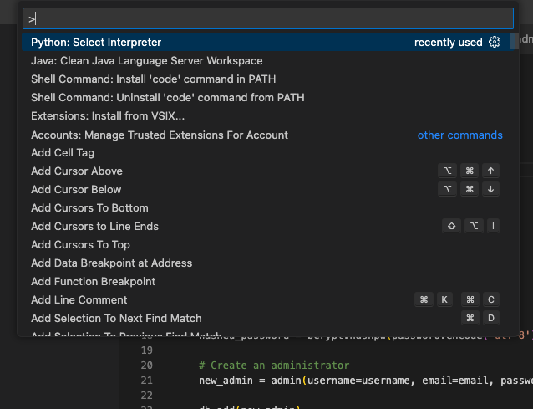
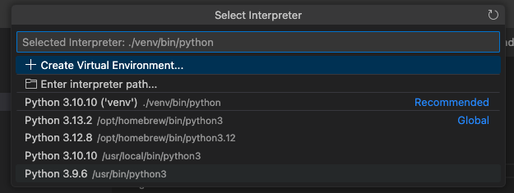
After completion, you will see the words as shown in the figure at the bottom right of the VScode interface.( In any case, you must ensure that you download the required Python version 3.10.10 or later from the Python official website. 3.10.10 is recommended.)
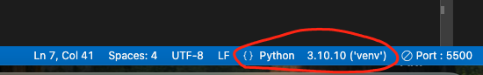
Use pip command in VScode terminal to download required python libraries：
pip install -r requirements.txt
Or find out the missing library and download it according to the error information
- Create data structures defined using Python(models.py).
Find the ".env" file and modify the username and password in the file to replace the name and password you set

Run “create_db.py “. If the creation is successful, you will see : ✅ The database table was created successfully!
After the database is created, you need to create a user. Only the created user can use the API to modify the database：
Use command: PYTHONPATH=$(pwd) python3 backend/create_admin.py
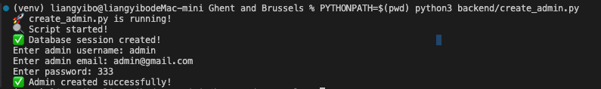
Now you have a user named admin with a password of 333.

- Then start the server locally
Use the command：
uvicorn backend.main:app --host 0.0.0.0 --port 8000 --reload
in the root directory of the project
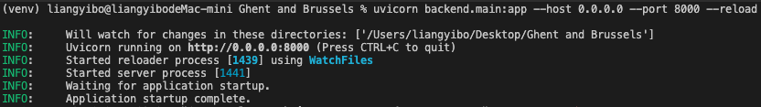
Visit http://127.0.0.1:8000/docs#/ in any browser to view and use these APIs.
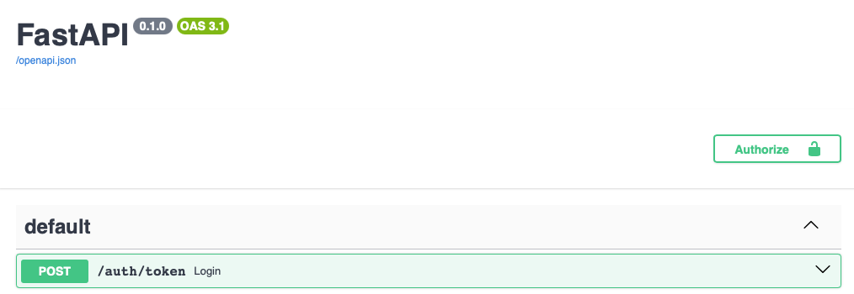
It is recommended to use Live Server
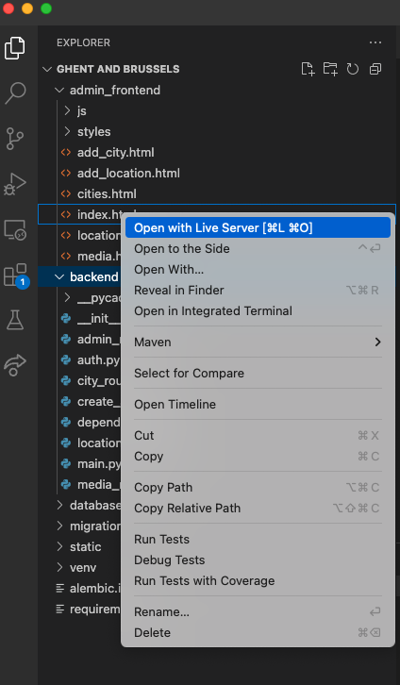
Click to open the front-end page in the default browser
The admin-frontend file contains code for how to use APIs.

